1. What are the various elements of the Excel interface? Describe how

they're used.

Ans: they are various types of elements some of them are explain below

* Quick access toolbar

This toolbar is located in the upper left corner of the screen. Its objective is to show the most frequently used Excel commands. We can customize this toolbar based on our preferred commands.

* File tab

We can click it to **check the Backstage view**, where we can **open** or **save files, create new sheets, print sheets**, and perform other **file-related operations**.

* Title bar

The title bar of the spreadsheet is at the top of the window. It displays the **active document's name.**

* Control buttons

Control buttons are the symbols that are present in the **upper-right side** of the window, enabling us to change the **labels, minimize, maximize, share,** and **close the sheet.**

* Menu bar

Under the **diskette** or **save icon** or the **excel icon** (this will depend on the version of the program**), labels** or **bars** which enable changing the sheet which is shown. These are the menu bar and contain a **File, Insert, Page Layout, Formulas,** **Data, Review, View, Help,** and a **Search Bar** with a **light bulb** icon. These menus are divided into subcategories which simplify the distribution of information and analysis of calculations.

* Tool bar

Each menu bar contains several different elements. On the selection of the menu, a sequence of command **options/icons** will show on a ribbon. For example, if we select the **"Home"** tab, we will see **cut, copy, paste, bold, italic, underline**, and **more** commands. In the same way; we can click on the **"Insert"** tab, we will see **tables, illustrations, additional, recommended graphics, graphics maps,** among others. On the other hand, if we select the **"Formulas"** option. **Insert functions, auto sum recently used, finances, logic, text, time, date,** etc.

2. Write down the various applications of Excel in the industry.

Ans: The main uses of excel incude

Data entry,data managent,accounting ,financial analysics,

Charting and graphing,title management

3. On the ribbon, make a new tab. Add some different groups, insert

commands in the groups and name them according to their commands

added. Copy and paste the screenshot of the steps you followed.

Ans: 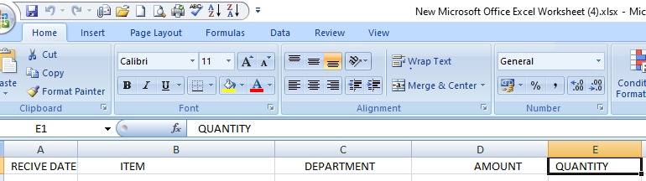

4. Make a list of different shortcut keys that are only connected to

formatting with their functions.

Ans: **Ctrl + M: Indent the paragraph.**

* **Ctrl + Shift + F: Change the font**
* **Ctrl + Shift + >: Increase selected font +1pts up to 12pt and then increases font +2pts**
* **Ctrl + ]: Increase selected font +1pts**.

5. What distinguishes Excel from other analytical tools?

Ans: **10 Essential Excel Features For Data Analysts to be uses in excel**

* Conditional formatting.
* Remove duplicates.
* XLOOKUP.
* IFERROR.
* MATCH.
* COUNTBLANK.
* DAYS and NETWORKDAYS.
* Pivot tables and pivot charts.

6. Create a table and add a custom header and footer to your table.

Ans: Go to Insert > Header or Footer. Choose from a list of standard headers or footers, go to the list of Header or Footer options, and select the header or footer that you want.

In other way

create your own header or footer by selecting Edit Header or Edit Footer. When you're done, select Close Header and Footer or press Esc.